

**NAME- TRUSHAA ATUL PANDYA**

**ROLL NO. - 12**

**SUBJECT- PHP AND MYSQL**

**TOPIC- "The Impact of Artificial Intelligence (AI) on Employment: A Comprehensive Analysis of Positive and**

**Negative Effects on Job Roles and Employee Dynamics."**

**SEMESTER-4**

**CLASS-M.COM (BUSINESS ANALYTICS)**

**INTERNAL PROJECT (2023-2024)**

**PROJECT GUIDE- Prof. Mr.Nikhil Mamaniya**

**S.P. MANDALI’S**

**R. A PODAR COLLEGE OF COMMERCE AND**

**ECONOMICS (AUTONOMOUS)**

**MATUNGA, MUMBAI-400 019.**

**CERTIFICATE**

This is to certify that **MS. TRUSHAA ATUL PANDYA** of M.Com part II (Business Analytics) Semester IV (2023-2024) has successfully completed the project on **"The Impact of Artificial Intelligence (AI) on Employment: A Comprehensive Analysis of Positive and Negative Effects on Job Roles and Employee Dynamics."** under the guidance of **Prof. Mr. Nikhil Mamaniya.**

Project Guide/

Internal Examiner External Examiner

Prof. Prof._________________

Dr.(Mrs.)Vinita Pimpale Dr.(Mrs.) Shobana Course Co-Ordinator Vasudevan Principal

**Date of Submission Seal of the College**

1. **Title And Introductory paragraph**

**CODES-**

<!DOCTYPE html>

<html>

<head>

<title>AI Impact on Employment Survey</title>

<div style="width: 80%; margin: auto; padding: 20px; border: 1px solid #ccc; border-radius: 10px; background-color: rgba(255, 255, 255, 0.8);"> <!-- Added border using HTML style attribute -->

<h1 style="text-decoration: underline; text-align: center;">AI Impact on Employment Survey</h1>

</head>

<head>

<body style="background-image: url('https://sageuniversity.edu.in/assets/images/blog/impact-of-artificial-intelligence-on-employment.png'); background-size: cover;">

</head>

<p style="font-size: 18px;">

Hello! My name is Ms. Trushaa Atul Pandya, and I am studying Masters in Business Analytics at R. A. Podar College, Matunga. The goal of my survey is to identify the challenges and opportunities presented by AI in the workforce, helping us navigate these changes effectively. Your participation is crucial in achieving insights that can guide strategies for a balanced integration of AI in the workplace.

<br><br>

Your valuable input will contribute to a comprehensive understanding of how AI influences job roles and employee dynamics.

Thank you for your valuable time and contribution!

</p>

<body>

<br>

**OUTPUT**

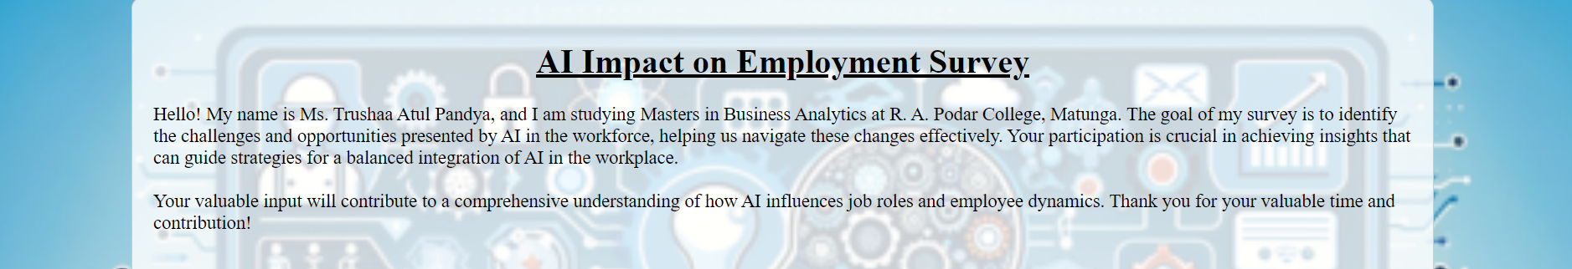

**2.BASIC DETAILS FOR FORM**

**CODE-**

<form action="<?php echo htmlspecialchars($_SERVER["PHP_SELF"]); ?>" method="post">

<div class="container">

<div style="width: 80%; margin: auto; padding: 20px; border: 1px solid #ccc; border-radius: 10px; background-color: rgba(255, 255, 255, 0.8);">

<p><b>Fill up the form with correct values.</p></b> <br>

<br>

<label for="firstname"><b>First Name</b></label>

<input type="text" name="firstname" required>

<label for="lastname"><b>Last Name</b></label>

<input type="text" name="lastname" required>

<label for="email"><b>Email Address</b></label>

<input type="email" name="email" required>

<label for="Age"><b>Age</b></label>

<input type="number" name="Age" min="1" max="100" required><br>

<label for="Gender"><b>Gender</b></label>

<select id="Gender" name="Gender" required>

<option value="Male">Male</option>

<option value="Female">Female</option>

<option value="Other">Other</option>

</select>

</div>

<?php

if(isset($_POST['submit'])) {

$firstname = $_POST['firstname'];

$lastname = $_POST['lastname'];

$email = $_POST['email'];

$age = $_POST['Age'];

$gender = $_POST['Gender'];

// Now you can process the form data as needed.

// For example, you can store it in a database, send an email, etc.

// Here, we'll just print the values for demonstration purposes.

echo "First Name: " . $firstname . "<br>";

echo "Last Name: " . $lastname . "<br>";

echo "Email Address: " . $email . "<br>";

echo "Age: " . $age . "<br>";

echo "Gender: " . $gender . "<br>";

}

?>

**OUTPUT**

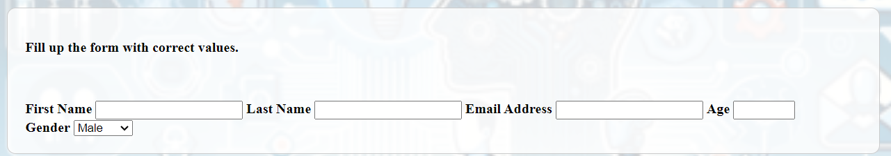

**3.MAIN QUESTIONS**

**CODE-**

<?php

// Initialize variables to hold form data

$q1 = $q2 = $q3 = $q4 = $q5 = "";

if ($_SERVER["REQUEST_METHOD"] == "POST") {

$q1 = $_POST["q1"];

$q2 = $_POST["q2"];

$q3 = $_POST["q3"];

$q4 = $_POST["q4"];

$q5 = $_POST["q5"];

}

?>

<div style="font-size: 18px;">

<form action="survey.php" method="post">

<!-- Q1 -->

<label for="q1">Q1. Do you believe AI has created more job opportunities?</label><br>

<input type="radio" name="q1" value="Yes" <?php if(isset($_POST['q1']) && $_POST['q1'] == 'Yes') echo 'checked'; ?>> Yes<br>

<input type="radio" name="q1" value="No" <?php if(isset($_POST['q1']) && $_POST['q1'] == 'No') echo 'checked'; ?>> No<br>

<input type="radio" name="q1" value="Maybe" <?php if(isset($_POST['q1']) && $_POST['q1'] == 'Maybe') echo 'checked'; ?>> Maybe<br>

<!-- Q2 -->

<label for="q2">Q2. Have you experienced job automation due to AI in your workplace?</label><br>

<input type="radio" name="q2" value="Yes" <?php if(isset($_POST['q2']) && $_POST['q2'] == 'Yes') echo 'checked'; ?>> Yes<br>

<input type="radio" name="q2" value="No" <?php if(isset($_POST['q2']) && $_POST['q2'] == 'No') echo 'checked'; ?>> No<br>

<input type="radio" name="q2" value="Not Sure" <?php if(isset($_POST['q2']) && $_POST['q2'] == 'Not Sure') echo 'checked'; ?>> Not Sure<br>

<!-- Q3 -->

<label for="q3">Q3. Do you think AI can perform tasks more efficiently than humans?</label><br>

<input type="radio" name="q3" value="Yes" <?php if(isset($_POST['q3']) && $_POST['q3'] == 'Yes') echo 'checked'; ?>> Yes<br>

<input type="radio" name="q3" value="No" <?php if(isset($_POST['q3']) && $_POST['q3'] == 'No') echo 'checked'; ?>> No<br>

<input type="radio" name="q3" value="Sometimes" <?php if(isset($_POST['q3']) && $_POST['q3'] == 'Sometimes') echo 'checked'; ?>> Sometimes<br>

<!-- Q4 -->

<label for="q4">Q4. Has AI influenced the skills required in your job?</label><br>

<input type="radio" name="q4" value="Yes" <?php if(isset($_POST['q4']) && $_POST['q4'] == 'Yes') echo 'checked'; ?>> Yes<br>

<input type="radio" name="q4" value="No" <?php if(isset($_POST['q4']) && $_POST['q4'] == 'No') echo 'checked'; ?>> No<br>

<input type="radio" name="q4" value="Somewhat" <?php if(isset($_POST['q4']) && $_POST['q4'] == 'Somewhat') echo 'checked'; ?>> Somewhat<br>

<!-- Q5 -->

<label for="q5">Q5. Do you believe AI will eventually lead to a more balanced work-life?</label><br>

<input type="radio" name="q5" value="Yes" <?php if(isset($_POST['q5']) && $_POST['q5'] == 'Yes') echo 'checked'; ?>> Yes<br>

<input type="radio" name="q5" value="No" <?php if(isset($_POST['q5']) && $_POST['q5'] == 'No') echo 'checked'; ?>> No<br>

<input type="radio" name="q5" value="Maybe" <?php if(isset($_POST['q5']) && $_POST['q5'] == 'Maybe') echo 'checked'; ?>> Maybe<br>

**OUTPUT**

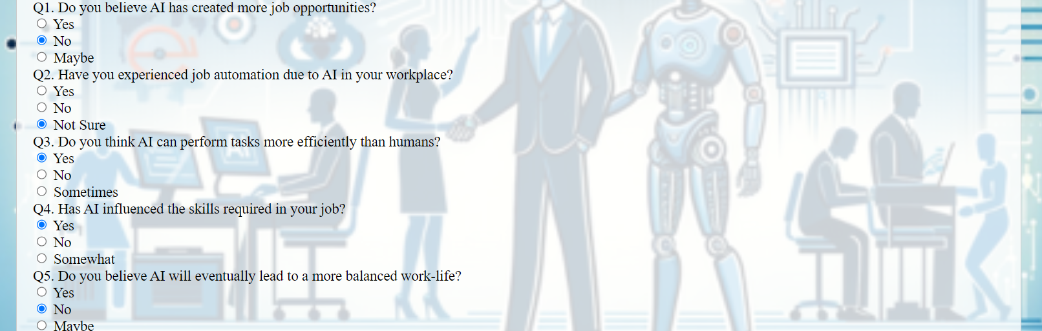

**4. SUB-QUESTIONS CODE ALONG WITH SUBMIT BUTTON**

**CODES-**

<!-- Sub-questions for Q1 -->

<?php

// Sub-questions for Q1

if ($q1 == "Yes") {

echo '<label for="q1a">Q1(A). If Yes: In which sectors, do you think AI has created the most job opportunities?</label><br>';

echo '<input type="checkbox" name="q1a[]" value="Healthcare"> Healthcare<br>';

echo '<input type="checkbox" name="q1a[]" value="Manufacturing"> Manufacturing<br>';

echo '<input type="checkbox" name="q1a[]" value="Retail"> Retail<br>';

echo '<input type="checkbox" name="q1a[]" value="Finance"> Finance<br>';

echo '<input type="checkbox" name="q1a[]" value="Other"> Other<br>';

} elseif ($q1 == "No") {

echo '<label for="q1b">Q1(B). If No: In which sectors, do you think AI has reduced job opportunities?</label><br>';

echo '<input type="checkbox" name="q1b[]" value="Healthcare"> Healthcare<br>';

echo '<input type="checkbox" name="q1b[]" value="Manufacturing"> Manufacturing<br>';

echo '<input type="checkbox" name="q1b[]" value="Retail"> Retail<br>';

echo '<input type="checkbox" name="q1b[]" value="Finance"> Finance<br>';

echo '<input type="checkbox" name="q1b[]" value="Other"> Other<br>';

}

?>

<!-- Sub-questions for Q2 -->

<?php

// Sub-questions for Q2

if ($q2 == "Yes") {

echo '<label for="q2a">Q2(A). If Yes: How has job automation impacted your role?</label><br>';

echo '<input type="checkbox" name="q2a[]" value="Enhanced productivity"> Enhanced productivity<br>';

echo '<input type="checkbox" name="q2a[]" value="Reduced tasks"> Reduced tasks<br>';

echo '<input type="checkbox" name="q2a[]" value="Increased job satisfaction"> Increased job satisfaction<br>';

echo '<input type="checkbox" name="q2a[]" value="Reduced job security"> Reduced job security<br>';

echo '<input type="checkbox" name="q2a[]" value="Other"> Other<br>';

} elseif ($q2 == "No") {

echo '<label for="q2b">Q2(B). If No: Do you feel threatened by the potential of job automation in the future?</label><br>';

echo '<input type="radio" name="q2b" value="Yes"> Yes<br>';

echo '<input type="radio" name="q2b" value="No"> No<br>';

echo '<input type="radio" name="q2b" value="Maybe"> Maybe<br>';

}

?>

<!-- Sub-questions for Q3 -->

<?php

// Sub-questions for Q3

if ($q3 == "Yes") {

echo '<label for="q3a">Q3(A). If Yes: Which of the following tasks, do you think AI excels at?</label><br>';

echo '<input type="checkbox" name="q3a[]" value="Data analysis"> Data analysis<br>';

echo '<input type="checkbox" name="q3a[]" value="Customer service"> Customer service<br>';

echo '<input type="checkbox" name="q3a[]" value="Creativity"> Creativity<br>';

echo '<input type="checkbox" name="q3a[]" value="Physical labour"> Physical labour<br>';

echo '<input type="checkbox" name="q3a[]" value="Other"> Other<br>';

} elseif ($q3 == "No") {

echo '<label for="q3b">Q3(B). If No: Which tasks, do you believe are better performed by humans?</label><br>';

echo '<input type="checkbox" name="q3b[]" value="Critical thinking"> Critical thinking<br>';

echo '<input type="checkbox" name="q3b[]" value="Emotional intelligence"> Emotional intelligence<br>';

echo '<input type="checkbox" name="q3b[]" value="Adaptability"> Adaptability<br>';

echo '<input type="checkbox" name="q3b[]" value="Innovation"> Innovation<br>';

echo '<input type="checkbox" name="q3b[]" value="Other"> Other<br>';

}

?>

<!-- Sub-questions for Q4 -->

<?php

// Sub-questions for Q4

if ($q4 == "Yes") {

echo '<label for="q4a">Q4(A). If Yes: What new skills do you think are necessary due to AI?</label><br>';

echo '<input type="checkbox" name="q4a[]" value="Coding/programming"> Coding/programming<br>';

echo '<input type="checkbox" name="q4a[]" value="Data analysis"> Data analysis<br>';

echo '<input type="checkbox" name="q4a[]" value="Machine learning"> Machine learning<br>';

echo '<input type="checkbox" name="q4a[]" value="Soft skills"> Soft skills (communication, teamwork)<br>';

echo '<input type="checkbox" name="q4a[]" value="Other"> Other<br>';

} elseif ($q4 == "No") {

echo '<label for="q4b">Q4(B). If No: Do you feel your current skills are becoming obsolete due to AI advancements?</label><br>';

echo '<input type="radio" name="q4b" value="Yes"> Yes<br>';

echo '<input type="radio" name="q4b" value="No"> No<br>';

echo '<input type="radio" name="q4b" value="Unsure"> Unsure<br>';

}

?>

<!-- Sub-questions for Q5 -->

<?php

// Sub-questions for Q5

if ($q5 == "Yes") {

echo '<label for="q5a">Q5(A). If Yes: How do you think AI will contribute to a balanced work-life?</label><br>';

echo '<input type="checkbox" name="q5a[]" value="Automation of repetitive tasks"> Automation of repetitive tasks<br>';

echo '<input type="checkbox" name="q5a[]" value="Remote work facilitation"> Remote work facilitation<br>';

echo '<input type="checkbox" name="q5a[]" value="Enhanced scheduling and time management"> Enhanced scheduling and time management<br>';

echo '<input type="checkbox" name="q5a[]" value="Improved mental health support"> Improved mental health support<br>';

echo '<input type="checkbox" name="q5a[]" value="Other"> Other<br>';

} elseif ($q5 == "No") {

echo '<label for="q5b">Q5(B). If No: What concerns do you have about the impact of AI on work-life balance?</label><br>';

echo '<input type="checkbox" name="q5b[]" value="Overworking due to AI capabilities"> Overworking due to AI capabilities<br>';

echo '<input type="checkbox" name="q5b[]" value="Reduced human interaction"> Reduced human interaction<br>';

echo '<input type="checkbox" name="q5b[]" value="Job insecurity"> Job insecurity<br>';

echo '<input type="checkbox" name="q5b[]" value="Work-related stress"> Work-related stress<br>';

echo '<input type="checkbox" name="q5b[]" value="Other"> Other<br>';

}

?>

<!-- Submit Button -->

<input type="submit" name="submit" value="Submit" style="background-color: red;font-size: 30px; text-align: center; display: block; margin: 0 auto;">

</form>

**OUTPUT**



Full form –

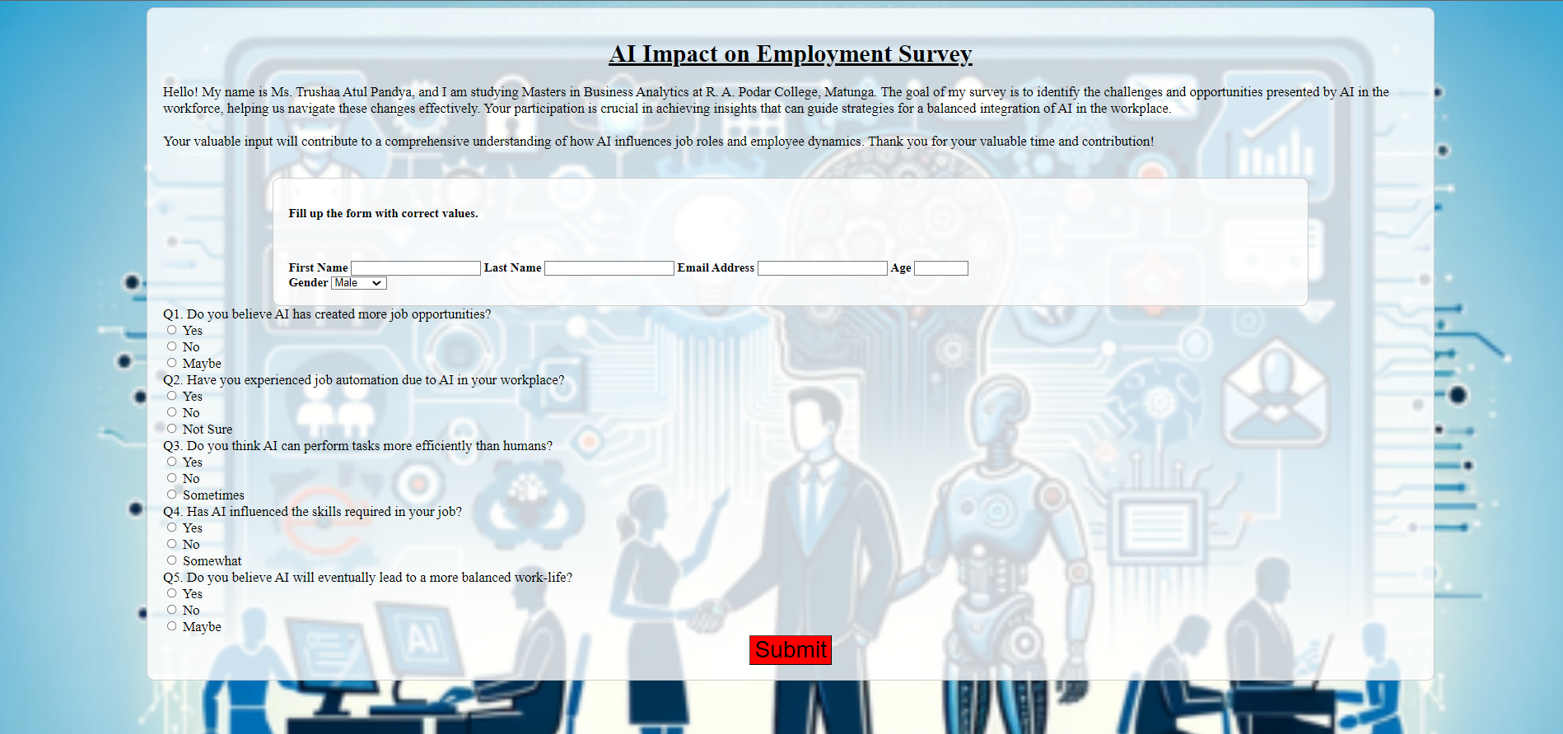

5. CONNECT PHP FORM TO MY SQL

**CODE-**

<?php

$conn = new mysqli("localhost", "root", "", "surveyDB");

// Initialize variables to hold form data

$q1 = $q2 = $q3 = $q4 = $q5 = "";

$q1a = $q1b = $q2a = $q3a = $q3b = $q4a = $q5a = $q5b = "";

if ($_SERVER["REQUEST_METHOD"] == "POST") {

$firstname = isset($_POST["firstname"]) ? $_POST["firstname"] : "";

$lastname = isset($_POST["lastname"]) ? $_POST["lastname"] : "";

$email = isset($_POST["email"]) ? $_POST["email"] : "";

$Age = isset($_POST["Age"]) ? $_POST["Age"] : "";

$Gender = isset($_POST["Gender"]) ? $_POST["Gender"] : "";

$q1 = isset($_POST["q1"]) ? $_POST["q1"] : "";

if(isset($_POST["q1a"])) $q1a = implode(", ", $_POST["q1a"]);

if(isset($_POST["q1b"])) $q1b = implode(", ", $_POST["q1b"]);

$q2 = isset($_POST["q2"]) ? $_POST["q2"] : "";

if(isset($_POST["q2a"])) $q2a = implode(", ", $_POST["q2a"]);

$q2b = isset($_POST["q2b"]) ? $_POST["q2b"] : "";

$q3 = isset($_POST["q3"]) ? $_POST["q3"] : "";

if(isset($_POST["q3a"])) $q3a = implode(", ", $_POST["q3a"]);

if(isset($_POST["q3b"])) $q3b = implode(", ", $_POST["q3b"]);

$q4 = isset($_POST["q4"]) ? $_POST["q4"] : "";

if(isset($_POST["q4a"])) $q4a = implode(", ", $_POST["q4a"]);

$q4b = isset($_POST["q4b"]) ? $_POST["q4b"] : "";

$q5 = isset($_POST["q5"]) ? $_POST["q5"] : "";

if(isset($_POST["q5a"])) $q5a = implode(", ", $_POST["q5a"]);

if(isset($_POST["q5b"])) $q5b = implode(", ", $_POST["q5b"]);

// Insert data into MySQL database

$sql = "INSERT INTO `survey_responses` (firstname, lastname, email, Age, Gender, q1, q1a, q1b, q2, q2a, q2b, q3, q3a, q3b, q4, q4a, q4b, q5, q5a, q5b) VALUES ('$firstname', '$lastname', '$email', '$Age', '$Gender', '$q1', '$q1a', '$q1b', '$q2', '$q2a', '$q2b', '$q3', '$q3a', '$q3b', '$q4', '$q4a', '$q4b', '$q5', '$q5a', '$q5b')";

if ($conn->query($sql) === TRUE) {

echo "New record created successfully";

} else {

echo "Error: " . $sql . "<br>" . $conn->error;

}

// Close connection

$conn->close();

}

?>

**OUTPUT-**

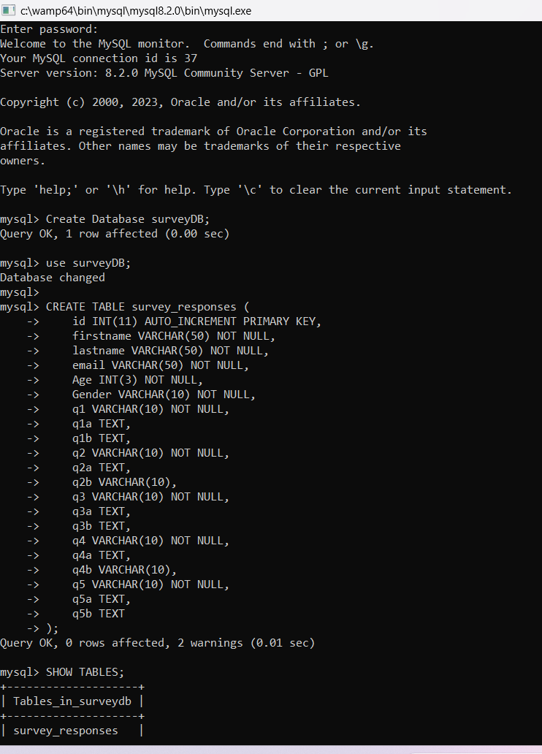

**6. FORM DATABASE TO MY SQL**

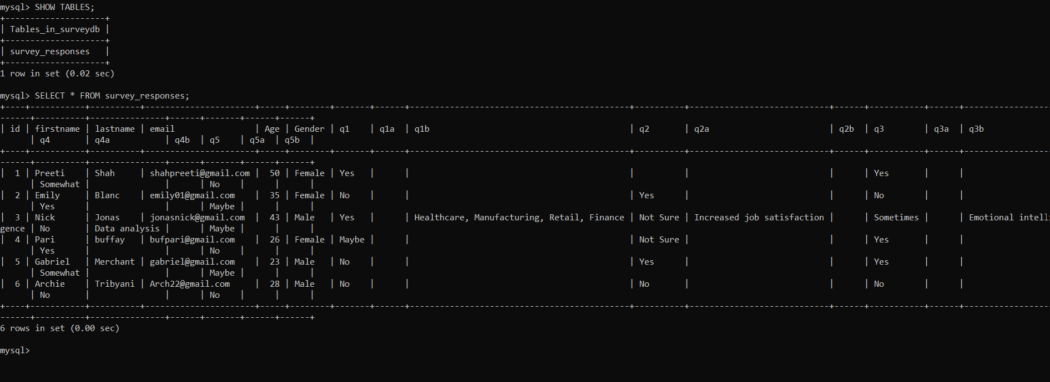

MY SQL –

Enter password:

Welcome to the MySQL monitor. Commands end with ; or \g.

Your MySQL connection id is 37

Server version: 8.2.0 MySQL Community Server - GPL

Copyright (c) 2000, 2023, Oracle and/or its affiliates.

Oracle is a registered trademark of Oracle Corporation and/or its

affiliates. Other names may be trademarks of their respective

owners.

Type 'help;' or '\h' for help. Type '\c' to clear the current input statement.

mysql> Create Database surveyDB;

Query OK, 1 row affected (0.00 sec)

mysql> use surveyDB;

Database changed

mysql>

mysql> CREATE TABLE survey_responses (

-> id INT(11) AUTO_INCREMENT PRIMARY KEY,

-> firstname VARCHAR(50) NOT NULL,

-> lastname VARCHAR(50) NOT NULL,

-> email VARCHAR(50) NOT NULL,

-> Age INT(3) NOT NULL,

-> Gender VARCHAR(10) NOT NULL,

-> q1 VARCHAR(10) NOT NULL,

-> q1a TEXT,

-> q1b TEXT,

-> q2 VARCHAR(10) NOT NULL,

-> q2a TEXT,

-> q2b VARCHAR(10),

-> q3 VARCHAR(10) NOT NULL,

-> q3a TEXT,

-> q3b TEXT,

-> q4 VARCHAR(10) NOT NULL,

-> q4a TEXT,

-> q4b VARCHAR(10),

-> q5 VARCHAR(10) NOT NULL,

-> q5a TEXT,

-> q5b TEXT

-> );

Query OK, 0 rows affected, 2 warnings (0.01 sec)

mysql> SHOW TABLES;

+--------------------+

| Tables_in_surveydb |

+--------------------+

| survey_responses |

+--------------------+

1 row in set (0.02 sec)

mysql> SELECT * FROM survey_responses;

+----+-----------+----------+----------------------+-----+--------+-------+------+--------------------------------------------+----------+----------------------------+------+-----------+------+------------------------+----------+---------------+------+-------+------+------+

| id | firstname | lastname | email | Age | Gender | q1 | q1a | q1b | q2 | q2a | q2b | q3 | q3a | q3b | q4 | q4a | q4b | q5 | q5a | q5b |

+----+-----------+----------+----------------------+-----+--------+-------+------+--------------------------------------------+----------+----------------------------+------+-----------+------+------------------------+----------+---------------+------+-------+------+------+

| 1 | Preeti | Shah | shahpreeti@gmail.com | 50 | Female | Yes | | | | | | Yes | | | Somewhat | | | No | | |

| 2 | Emily | Blanc | emily01@gmail.com | 35 | Female | No | | | Yes | | | No | | | Yes | | | Maybe | | |

| 3 | Nick | Jonas | jonasnick@gmail.com | 43 | Male | Yes | | Healthcare, Manufacturing, Retail, Finance | Not Sure | Increased job satisfaction | | Sometimes | | Emotional intelligence | No | Data analysis | | Maybe | | |

| 4 | Pari | buffay | bufpari@gmail.com | 26 | Female | Maybe | | | Not Sure | | | Yes | | | Yes | | | No | | |

| 5 | Gabriel | Merchant | gabriel@gmail.com | 23 | Male | No | | | Yes | | | Yes | | | Somewhat | | | Maybe | | |

| 6 | Archie | Tribyani | Arch22@gmail.com | 28 | Male | No | | | No | | | No | | | No | | | No | | |

+----+-----------+----------+----------------------+-----+--------+-------+------+--------------------------------------------+----------+----------------------------+------+-----------+------+------------------------+----------+---------------+------+-------+------+------+

6 rows in set (0.00 sec)

**________________________________THANK YOU _________________________________**

**Sir As my Phpmyadmiin wasn’t working so instead of this form details are seen in MY SQL.**

**Sir, I had tried every possible thing from reinstalling wamp and etc but it didn’t happen.**

**Thank you sir.**

